YEAR 11 ATAR Course Examination
Question/Answer Booklet

ECONOMICS Units 1 & 2

Semester 2 2019

Student number:

Time allowed for this paper
Reading time before commencing work: ten minutes
Working time for paper: three hours

Materials required/recommended for this paper
To be provided by the supervisor
This Question/Answer Booklet
Multiple-choice Answer Sheet
Two separate booklets for your extended answers

To be provided by the candidate
Standard items: pens (blue/black preferred), pencils (including coloured), sharpener,
correction fluid/tape, eraser, ruler, highlighters
Special items: non-programmable calculators approved for use in the WACE examinations

Important note to candidates
No other items may be taken into the examination room. It is your responsibility to ensure that you do not have any unauthorised material. If you have any unauthorised material with you, hand it to the supervisor before reading any further.

Structure of this paper

Section | Number of questions available | Number of questions to be answered | Suggested working time (minutes) | Marks available | Percentage of examination
Section One  Multiple-choice | 24 | 24 | 30 | 24 | 24
Section Two  Data interpretation / Short answer | 3 | 3 | 70 | 36 | 36
Section Three  Extended answer | 4 | 2 | 80 | 40 | 40
 |  |  |  | Total | 100

Instructions to candidates

1. Answer the questions according to the following instructions.

Section One: Answer all questions on the separate Multiple-choice answer sheet provided. For each question, either place a cross over the correct answer or shade in the correct answer. Use only a blue or black pen. If you make a mistake, place a cross through that square, then select your new answer. Do not erase or use correction fluid/tape. Marks will not be deducted for incorrect answers. No marks will be given if more than one answer is completed for any question.

Sections Two: Write your answers in this Question/Answer Booklet.
Section Three: Write each answer in a separate booklet.

2. You must be careful to confine your answers to the specific questions asked and to follow any instructions that are specific to a particular question.

3. Supplementary pages for the use of planning/continuing your answer to a question have been provided at the end of this Question/Answer booklet. If you use these pages to continue an answer, indicate at the original answer where the answer is continued, i.e. give the page number.

See next page

Section 1: Multiple-choice (24 Marks)
This section has 24 questions. Answer all questions on the separate Multiple-choice answer sheet provided. For each question, either place a cross over the correct answer or shade in the correct answer. Use only a blue or black pen to shade the boxes. If you make a mistake, place a cross through that square, then select your new answer. Do not erase or use correction fluid/tape. Marks will not be deducted for incorrect answers. No marks will be given if more than one answer is completed for any question.
Suggested working time: 30 minutes
____________________________________________________________________________

- The diagram represents the production possibility frontier of a country.
Which one of the following is correct?

- In a free market, production would consist of 0X capital goods and 0Y consumer goods
- Position C represents greater existing output of consumer goods relative to capital goods
- Position A would create larger potential future capacity than position B
- Position A is more productively efficient than position B

- If Ms Reilly is willing to pay $200 for a new outfit but is able to buy one for $150, her consumer surplus is:

  - $350
  - $200
  - $150
  - $50

- The opportunity cost of going to the movies instead of studying for your economics exam is:

  - the time you could have spent studying
  - the satisfaction derived from watching the movie would mean there are no costs
  - a monetary value of the ticket
  - the cost of the movie ticket and the lost time you could have used studying

- If supply is greater than demand then

  - demand will expand
  - downward pressure is applied to prices
  - a shortage exists
  - an economy must be in a boom

- All other things being equal, a supply curve slopes upward from left to right because higher prices will

      - cause an expansion in supply
      - result in a shift in the supply curve
      - lead to increased profits
      - attract scarce resources from low value uses to higher value uses

  - (i), (ii) and (iii)
  - (ii), (iii) and (iv)
  - (i), (iii) and (iv)
  - (i), (ii) and (iv)

- Consider the market for mobile phones. Which of the following would decrease the demand for mobile phones?

  - studies showing using mobile phones can cause brain cancer
  - a decrease in the price of mobile phones
  - new technology allows mobile phones to be used as satellite phones
  - an increase in the price of mobile phones

- Suppose that in October the price of a cup of coffee was $3.00 and 400 cups were consumed. In November the price of a coffee was $4.00 and 600 cups were consumed. Which of the following might have caused this change?

  - The price of tea fell
  - The price of tea rose
  - The price of coffee beans rose
  - The price of coffee beans fell

- Average income increases from $20,000 p.a. to $22,000 p.a. Quantity demanded per year increases from 5000 to 6000 units. Which of the following is correct?

  - Demand is price inelastic
  - The good is inferior
  - Income elasticity is -2
  - The product has a positive income elasticity of demand

- Melissa must always have cream in her coffee. For Melissa, the cross-price elasticity of demand for coffee and cream is

  - equal to 0
  - negative
  - positive
  - impossible to determine without more information

- Governments wishing to maximise revenue should tax goods which have

  - a low price elasticity of demand
  - a high price elasticity of demand
  - a low cross elasticity of demand
  - a high income elasticity of demand

- The diagram below depicts a situation in which the government has granted a subsidy to producers of milk.

Which area represents the total sum spent by the government on subsidies?

  - CADE
  - BFEC
  - 0BFQ1
  - 0CEQ

- The free rider effect is only present in

  - Common Property Goods
  - Private Goods
  - Club Goods
  - Public Goods

- Which of the following are leading indicators?

  - Retail sales figures, inflation rate
  - Unemployment rate, quarterly GDP growth
  - Share price index, wage rate
  - Consumer and business confidence, home building approvals

- Which one of the following transactions would be counted in the calculation of GDP?

  - A gardener plants flowers in his own garden
  - A boy swaps his old skates for new ones with a friend
  - A man buys 100 shares of stock in XYZ Corporation
  - Classic Cars manufactures 3,000 automobiles and holds them as inventory (stock)

- The national income is initially in equilibrium.
If there was a decrease in exports, which change would restore national income to its initial equilibrium level?

- An equivalent decrease in investment
- An equivalent decrease in tax revenue
- An equivalent increase in government expenditure on goods and services
- An equivalent increase in saving

- John, a car mechanic from Detroit has been out of a job since his company increased the automation of their production processes. Since then he has been frantically looking for a job, going to the agencies every single day. John is part of the ____ .

  - cyclical unemployment figures
  - frictional unemployment figures
  - structural unemployment figures
  - discouraged workers figures

- The weight for a product in the consumer price index was increased. What is most likely to have caused this adjustment?

  - The product has become more expensive to produce
  - The product has taken a larger share of consumers’ income
  - The product has been offered for sale in more retail outlets
  - The product has improved in quality and performance

- In 2018, William's nominal income increased by 3%, while the price level rose by 1%. Consequently, William's real income:

  - rose by approximately 4%
  - fell by approximately 1%
  - rose by approximately 2%
  - fell by approximately 2%

- A woman earns $20 per hour and the price index = 100. Other things being equal, what would her real salary be if the price index rose to 110?

  - $16
  - $18
  - $20
  - $22

- A tax that takes a smaller percentage of income as the income increases is called:

  - a regressive tax
  - a progressive tax
  - a proportional tax
  - an excise tax

- From the perspective of individuals, the goods and services tax (GST) applies to:

  - additional income earned
  - expenditure rather than income
  - profits for self-employed individuals
  - saving rather than expenditure

- The provision of public housing (i.e. state housing) is an attempt to increase:

  - Competition
  - Equity
  - Efficiency
  - Productivity

- In an economy's balance of payments account,
  - the capital and current accounts must add to one
  - both the balance on current account and the balance on capital account are zero
  - the capital and financial account plus current account balances must equal zero
  - capital outflows must equal capital inflows

- Ms Joll has bought $10 000 worth of shares in a French-based vineyard. This would be recorded on the balance of payments as:

  - Credit on the balance of goods and services
  - Debit on the balance of goods and services
  - Credit on the financial account
  - Debit on the financial account

_____________________________________________________________________________

End of Section One

See next page

Section Two: Data interpretation/Short answer (36 Marks)

This section contains three (3) questions. Answer all questions. Write your answers in the
spaces provided.
Supplementary pages for the use of planning/continuing your answer to a question have been provided at the end of this Question/Answer booklet. If you use these pages to continue an answer, indicate at the original answer where the answer is continued, i.e. give the page number.
Suggested working time: 70 minutes.
_____________________________________________________________________________

Question 25 (12 marks)
In the wake of a drone attack on Saudi oil fields, Australian motorists may feel the impact at the petrol bowser.
By Camille Bianchi (SBS News)

Australian motorists have been warned they won't be immune from the impact of drone strikes on oil fields in Saudi Arabia. The attacks on oil fields owned by supplier Aramco are expected to strip at least five per cent from global oil supplies, with some analysts predicting wholesale barrel prices could increase by 50 per cent. As the Australian market factors in the weekend's events, Scott Phillips, Chief Investment Officer of Motley Fool Australia said consumers should expect price hikes in line with those in other developed markets. "Oil is the most international commodity there is, so to imagine we won't feel a price shock - even due to competition meaning oil can be sold at higher prices elsewhere - does not add up," he said.

- From the extract, identify the expected increase in oil prices. (1 mark)

- Identify and explain the impact of the increase in oil prices on inflation in Australia.
(2 marks)

- Describe and explain the price elasticity of demand for petrol. (4 marks)

- Using an appropriate model, demonstrate and explain the likely impact of the drone strikes on the Australian petrol market. (5 marks)

This page has been left blank intentionally

Please turn over the page for the next question.

Question 26 (12 marks)

Figure 1. Changes of Gross Domestic Product (GDP) in %

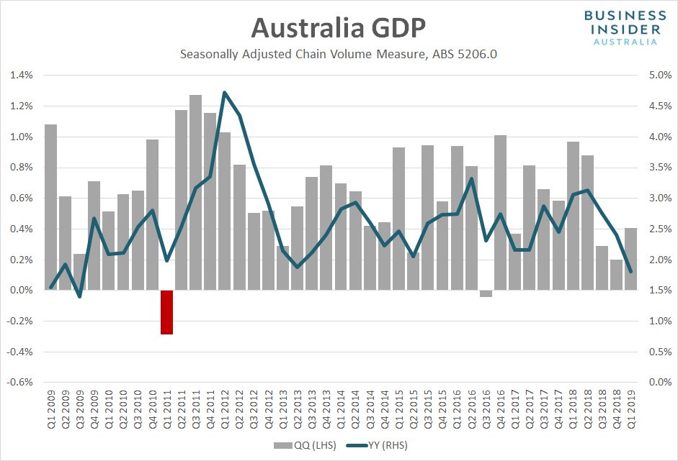

- Explain the term business cycle. (2 mark)

- With reference to figure 1, state the trend in the GDP growth rate from 2016 to 2017.
(1 marks)

- With reference to the GDP growth trend from 2012 to 2013, state and describe the phase of the business trade cycle that would correlate with the stated period. Ensure that you justify your response. (5 marks)

- Describe the costs and benefits of economic growth. (4 marks)

Question 27 (12 marks)

Record trade surplus for Australia
DFAT Media release 6 August 2019

Australia’s export sector continues to boom with new data showing Australia recorded its largest ever financial year trade surplus. New data released today from the Australian Bureau of Statistics show that Australia posted a record trade surplus of $49.9 billion for the 2018-19 financial year. “Despite global trade headwinds, Australia’s six largest monthly trade surpluses have all been recorded in 2019, with Australia also now recording 18 consecutive monthly trade surpluses, an achievement that has not occurred since 1972-1973. “However, the impact of global trade tensions and volatility of commodity prices means that there is no room for complacency and there are many threats to be managed.

- From the excerpt, state the trade balance in the 2018-19 financial year. (1 mark)

- With reference to the excerpt, state the two threats to our trade surplus that are mentioned.
(1 mark)

- Describe the trends in Australia’s direction and composition of trade. (2 marks)

- Describe the components of the current account. (4 marks)

- Explain the relationship between Australia’s current account and the capital and financial account. (4 marks)

End of Section Two
See next page
Section Three: Extended answer (40 Marks)

This section contains four (4) questions. Answer two (2) questions. Write the answers in the separate booklets provided and number your answers clearly.
Suggested working time: 80 minutes.
_____________________________________________________________________________

Question 28 (20 marks)

- Explain income elasticity of demand and cross elasticity of demand. (8 marks)

- Explain the significance of price elasticity of demand and price elasticity of supply to consumers, businesses and the government. (12 marks)

_____________________________________________________________________________

Question 29 (20 marks)

Due to the problems associated with obesity there have been calls for the Australian Government to introduce a sugar tax.

- Using appropriate diagrams, explain how externalities create market failure.
(8 marks)

- Explain how the government could reduce consumption externalities. Include diagrams where relevant. (12 marks)

_____________________________________________________________________________

Question 30 (20 marks)

- Using examples, identify and explain the causes of inflation. (10 marks)

- Describe how firms and households may be affected by an increase in the rate of inflation and explain why governments seek to pursue a low and stable rate of inflation. (10 marks)

____________________________________________________________________________

Question 31 (20 marks)

- Describe the concepts of income and wealth and explain how the distribution of income and wealth is measured. (10 marks)

- Explain how Australia’s tax system measures against the criteria of being equitable, efficient and simple. (10 marks)

_____________________________________________________________________________

End of questions

Supplementary writing pages

